SELF-STUDY VISITING COMMITTEE REPORT
WESTERN ASSOCIATION OF SCHOOLS AND COLLEGES
CALIFORNIA STATE DEPARTMENT OF EDUCATION
for
SANTA YNEZ VALLEY UNION High School
2975 E. Highway 246
Santa Ynez, California 93460
Santa Ynez Valley Union High School District
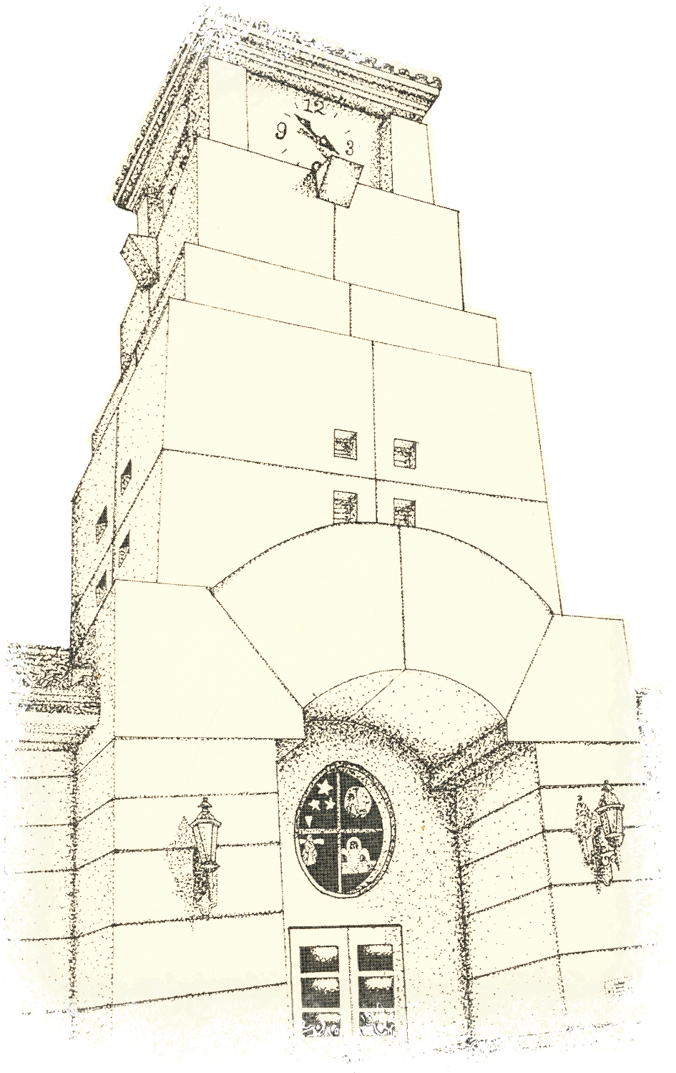
February 27-29, 2012
Visiting Committee Members
Skip Nicholson, Visiting Committee Chair
South Pasadena High School, South Pasadena
Elizabeth Bartolomea
Grant High School, Los Angeles, Retired
James Martinez
Principal, Las Posas Elementary School, Camarillo
Sean McNamara
Assistant Principal, Tesoro High School, Las Flores
Jeanie Mortensen
Northridge Academy High School, Northridge
Bernard Yost
Assistant Principal, Sonora High School, La Habra
Chapter I: Student / Community Profile

STUDENT/COMMUNITY PROFILE
Founded in 1896, Santa Ynez Valley Union High School is a 9-12 comprehensive high school in Northern Santa Barbara County on an attractive and impeccably maintained campus. It serves just over 1000 students and has long been both a social center of life in the Valley and a focal point of tradition and pride. Many families at the high school have roots that run back generations. The school and Refugio High School, a continuation school on the same campus, make up the Santa Ynez Valley Union High School District.
The median income in the Valley is about $70,000 per household with the median home price at about $700,000. The Valley population of a steady 22,000 is currently about 75% White and about 20% Hispanic with the remaining 5% divided among Native Americans, Asians and African-Americans. The local economy is reasonably solvent with property taxes providing for a stable annual site budget and Basic Aid status for the school. A diversified local income base draws revenue from wine and agricultural industries and tourism. The largest employer is the Chumash Casino Resort, operated by the Santa Ynez Band of Chumash Indians, and family professions range from ranch workers to retired millionaires and vineyard owners. Some families have no education beyond grade school; others boast PhDs.
The staff of this, the sole public high school in a small, close knit Valley, knows the students well, from both on- and off-campus activities. Many of the students have been together through much of their education. Administration communicates with families through newsletters, telephone reminders, and progress reports.
The school population has decreased slightly each year from 1120 in 2008 to its current 1005. In that time, though, the Hispanic population’s portion has grown by 25%, the el population has risen from 16% to 20% of the student body, and the number of students with special needs has doubled. In a unique arrangement, the Santa Ynez Valley Special Education Consortium provides contracted Special Ed services to the students and staff. Over a quarter of the students are enrolled in the rigorous Advanced Placement and dual enrollment programs. Enrollment in higher math and science courses has at least doubled for all ethnicities. Still, the school sees a lag in Hispanic enrollment in higher level courses.
Average monthly attendance has held fairly steady at or near 95% over the past several years. The district and school administrations are exploring ways of offsetting the practice of many Hispanic families of taking extended trips out of the country during the winter holidays. There is a consistent annual schoolwide student attrition rate fluxating between 3% and 5%. The school culture aggressively supports safety and order, and most disciplinary infractions are mild. Tardiness accounts for two-thirds of all referrals. Of the more hazardous violations of property damage, fighting, drug or tobacco possession, theft, and possession of weapons, none accounts for more than 1.3% of all referrals.
A California Distinguished High School and a ctap II supported Digital High School, it oversees the county’s largest Regional Occupation Program (rop). The school boasts a long-time avid program, an honored Environmental and Spatial Technologies (east) program, and a robust agriculture education program. There is an active ptsa, and support comes from a variety of groups including abc+, the Santa Ynez Band of Chumash Indians, the Valley Foundation, the Elks, and Rotary. The school has been designated a Targeted Title 1 School with a focus on at-risk students. It funnels funding into a variety of at-risk targeted resources and programs.
The school provides an attractive, clean, safe, well-groomed and unusually well-maintained learning environment.
The well-qualified, professional staff takes great pride in its work. The energetic and committed teaching staff are all fully credentialed, all teaching in their areas of specialization and all clad-certified. Their district, county, state, and national honors form an impressive list, including California State Teacher of the Year, and they host an array of clubs, teams, and extracurricular activities. Two thirds have been at the school for over a decade. The administration supports teacher experimentation and risk-taking while providing guidance, encouragement, and support.
Decisions concerning staff development are made by the principal and school leadership team using tools such as the District Strategic Plan, state assessment results, and data analysis to find the areas in which additional teacher training may enhance classroom instruction and increase student achievement. Staff development is centered on the State Content Standards and Frameworks. Depending on the level of state funding, two to three formal staff development days are devoted to data analysis, instructional strategies, and the wasc review. Over a third of the staff has attended an avid training. Over a quarter have attended ap or ib conferences or both.
New and veteran teachers are supported through peer coaching and mentoring. Instructional aides are provided targeted training focused on teaching strategies and curriculum content. Substitute teachers are invited to participate in designated staff development activities. All staff are encouraged to attend professional workshops and conferences. Classified support staff members receive job-related training from department supervisors and district representatives. Teachers actively seek out professional conferences and associations. The administration continues to seek ways to assist teachers with release time, funding, and salary credit. During the summer months teachers have participated in in conferences such as the avid Summer Institute, the South Coast Writing Project (scwrip) and various ap and subject-matter projects statewide. There is a prevalent culture among the teachers of continual refinement, improvement and renewal.

Student Performance Data
For the California Academic Performance Index (api), the school has met its schoolwide targets for the past three years, with the growth score remaining above the 800 benchmark. All subgroups met the targets for 2009-10, although not in 2008-09 nor 2010-11.
API Growth Targets
API | Base | Growth | Growth Score | Schoolwide Met Target | Subgroups Met Target | Statewide Rank | Similar Schools Rank
2010-11 | 844 | - 18 | 826 | Yes | No | 9 | 9
2009-10 | 816 | + 28 | 844 | Yes | No | 9 | 7
2008-09 | 795 | + 21 | 816 | Yes | No | 9 | 6
The school has found slightly less success maintaining Adequate Yearly Progress. Although meeting all 22 ayp criteria in 2009, the school has seen two heavily overlapping sub-groups fall short in the last two years: Hispanic students and Socio-Economically Disadvantaged students. During the same time, those two groups were growing significantly. In 2011, students scoring below proficient included 38 Hispanic, 31 disadvantaged, and 29 English learners in math and 34 Hispanic students in English. Identified for Program Improvement, Year 1, the school has named these subgroups as its focus with special attention to math. Working with the Santa Barbara County Education Office, the school has aligned its Local Education Agency Plan (leap) for the pi process with its wasc Action Plan. The primary goals, closely aligned to the goals in the wasc Action Plan are to:
- Increase attention to and resources for el students.
- Increase attention to and resources for low-performing math and ela students.
- Revisit and expand existing tutorial structure.
Over the last three years the api score have gone from 816 to 844 to 826. The school has analyzed data from the state and found that (1) a stronger or weaker 9th graders outperform older students, (2) departments find difficulty achieving passing percentages higher than 70%, and (3) the majority of students who do not pass the tests score ‘Basic.’
In celdt testing, roughly 80% score Intermediate or Advanced. Because of the increasing Hispanic enrollment, the school finds it important to monitor students and to sync planning and pedagogy to those growing numbers.
The Advanced Placement program flourishes in fourteen subjects with solid enrollment and, in twelve of them, strong participation in the national exams.
Chapter II: Progress Report
Over the past six years, the staff has worked to ensure that the community is aware of and supports the site goals and accomplishments while simultaneously keeping stakeholders apprised of how the staff and leaders are meeting the needs of a changing population and the expanding expectations of academic rigor. The school has ensured that the site remain open to the public by hosting a broad range of events ranging from youth football and rifle club to and adult jazz band and children’s musical theater.
The staff has focused on having a high percentage of students complete the UC a-g requirements while mastering the skills they will need to succeed in college and, at the same time, to help all students find worthwhile ways to contribute to the greater good with a sense of pride in themselves.
Innovations include a “Coffee with the Principal” program, a change in the hours of the Board’s monthly meeting to encourage greater attendance, the addition of wasc student and parent committees, and increasing the participation of the Hispanic community through newsletter translations and evening computer classes to help Spanish speaking parents navigate school email and the “Pirate Portal” opportunities to stay connected to school.
Since the last wasc visit the school has seen a weighty change in its Board and administration. All five Board members are new to the site as are the superintendent, principal, assistant principal, business manager, director of maintenance and operations, and a number of other critical administrative support staff members. There is now one assistant principal instead of two. The change resulted primarily from a general community desire to become more involved. A sudden and robust community interest in school visions and goals led to energetic public debates resulting in a field of candidates and elected members representing a wider variety of visions for education. These events, well-covered by the media, have reenergized community buy-in. The resulting change in leadership came as a direct result of the new board. Support for this adjustment has been generally strong among staff and faculty members.
To enhance its focus on the advancement of English Learners, 100% of the faculty has become clad certified since the last wasc Focus on Learning visit. The process has enlivened and expanded the methodology of teaching.
Over the last half decade, advances in technological capability have enhanced instruction schoolwide, and additional software has been added as specifically relevant to individual subjects. In addition to its instructional use, new software has enabled on-line attendance and grade management. Access through the Aeries software allows any teacher see a more complete picture of the needs and habits of each student while streamlining communication with counseling, discipline and teaching colleagues.
The most significant development in the past six years has been the change in campus demographics, especially the increasing numbers of Hispanic students, of socio-economically disadvantaged students, of students limited in English proficiency, and of those designated as Special Education. Anticipating a continuation of these trends over the next half decade, the school is focusing much of its Focus on Learning attention to these subgroups.
The school shares the challenges of the continuing economic downturn. A major stadium-building project planned and started in better times has brought a depletion of reserves and committed the district to annual loan payments and to the replacement of depleted savings. The school has worked to control spending, and in spite of the current slump in the housing market, local property taxes from older home sales still generate a significant income. The school is currently a Basic Aid school and has no plans to slow innovation and improvement.
After several years as the top scoring high school in the county, the school has been flagged for Program Improvement. The State named the 40 sophomores failing to meet the Federal targets as Hispanic or Latino, Socio-Economically Disadvantaged, and English Learners. So three of the four Critical Academic Needs now relate to this population. During the Fall 2011 semester, a Program Improvement partnership began with the Santa Barbara County Education Office. The County team has met with District and site leadership, observed the faculty teaching, shadowed students representative of the underperforming sub-groups, and provided an afternoon in-service for the faculty. Likewise, the county Program Improvement support team took part in the wasc Chapter 5 planning session to help ensure that the wasc goals and target groups were consistent with Program Improvement needs.

Steps Taken to Implement the Action Plan
The school has attended to the recommendations and concerns of both the faculty and the 2006 wasc visiting committee.

Goal 1: Improve communication with Hispanic families and
Goal 3: Improve and expand support for el students.
- Written and oral communication from the office are now in English and Spanish, as are Aeries Gradebook reports, progress and grade reports, and the pta Newsletter.
- Spanish speaking faculty continue to provide training in the “Pirate Portal,” the gateway to student records and assignments as well as faculty websites and email.
- A fulltime bilingual counselor now serves Spanish-speaking students and parents, and all classified faculty are now clad certified.
- The wasc Parent Committee contains and Spanish Speaking sub-group with an interpreter.
- The first results of these efforts include significantly increased attendance during Hispanic Parent Nights and el students using The Pirate’s Cove as a center to organize socially.

Goal 2: Assist remedial and academically at-risk students to improve their ability and success
- Institution of a mandatory period 7 Credit Recovery class for students deficient in units
- Institution of mandatory cahsee classes in addition to regular language arts and math classes
- Implementation of Scholastic’s Read 180 in addition to regular language arts classes
- Implementation of Pirate Portal for improved communication with parents
- Implementation of eight grade reporting periods throughout the school year
- Implementation of tutorials during lunch, period 7 and after school
- Supervised, academic in-house suspension
- Requirement of UC a-g language arts and social studies courses for all students
- Aeries access to all student interventions, records, and grades
- Creation of a safe social haven for at-risk students at the Pirates Cove

Goal 4: Improve the effectiveness and efficiency of Special Education and 504 Programs
- Formation of a strong partnership with the Santa Ynez Valley Special Education Consortium
- Increased mainstreaming of Special Ed students with Special Ed support staff in the classroom
- Institution of a new model of inclusion of Special Ed students into regular a-g core classes
- Improvement working relationship and communication between Special Ed teachers and mainstream classroom teachers
- Provision of individual Special Ed binders to provide teachers with special needs information for each student
- Inclusion of easily accessed Special Ed information on the Aeries desktop attendance and grading program
- Achievement of a significant increase in teacher use of multiple instructional strategies in mainstream classes
- Improvement in overall site pedagogy related to clad, Sheltered, el, sdaie, and avid

Goal 5: Integrate the eslrs into the school culture

Motivated Self-Directed Learners
To provide the students with a learning structure designed to model organization, planning and self-reliance, the staff uses student directed projects, presentations, and research assignments. Students are expected to demonstrate an ability to produce model work that results from self-directed research and planning. Teachers scaffold student expectations on small projects or presentations that set the stage for larger ones. They provide clear expectations and provide a number of forums where students take control of their learning. Students have access to online teacher websites and are responsible for accessing assignment reminders and handouts. Teachers encourage students to research content and write papers of their own choosing. The faculty work to convey the message to all students that the staff will provide the necessary tools and strategies but the work must come from the students.

Effective Communicators
Over the past half decade the faculty has increased its demand for polished and thoughtful student communication. Student speeches, skits, songs, presentations, video projects and debates have long been a part of daily curriculum. The students have developed into individuals who understand the importance of a public voice. They respect varying viewpoints, pause to listen and, more importantly pause to develop ideas. The new generation of students seems to think in terms of finding a way to communicate thought. The school produces well-attended and dynamic theater productions, schoolwide chalk festivals, art productions, highly creative computer produced posters and even a style of clothing that speaks to the notion of unique and effective communication.

Responsible Citizens
The school takes pride in being a place rich in personal ethics and positive civic participation. Students have felt confident in finding ways to carve out personal forums of civic participation. Many students seek out leadership positions in a wide variety of organizations, both on and off campus. Students volunteer around the Valley, from bell-ringing at Christmas to singing at the Senior Center.

Informed Critical Thinkers
Students learn to evaluate primary sources in history and to critically analyze literature in English. Mathematics is a continual and linked series of scaffolds, where students apply understandings to new situations. The World Language program guides students to a better understanding of the relationship among cultures. Science especially teaches the interdependence of content and application, of data, prediction and evaluation.

Competent Technology Users
Students benefit from state of the art computers, high speed internet access, up-to-date software and operating systems, remote printing. desktop publishing software, dvd players, and permanent ceiling-mounted projectors. Teachers continue to acquire digital cameras, photo manipulation software, document cameras and interactive projectors. Curriculum developments designed to support student technological growth include a variety of popular rop courses in digital photography, computer research and data manipulation, visual tech creation and filmmaking. In the yearbook course students demonstrate mastery to deliver a satisfactory product. Students are expected to show mastery of presentation software and Internet information skills. Each academic department has made a formal presentation to the School Board highlighting technological advances.

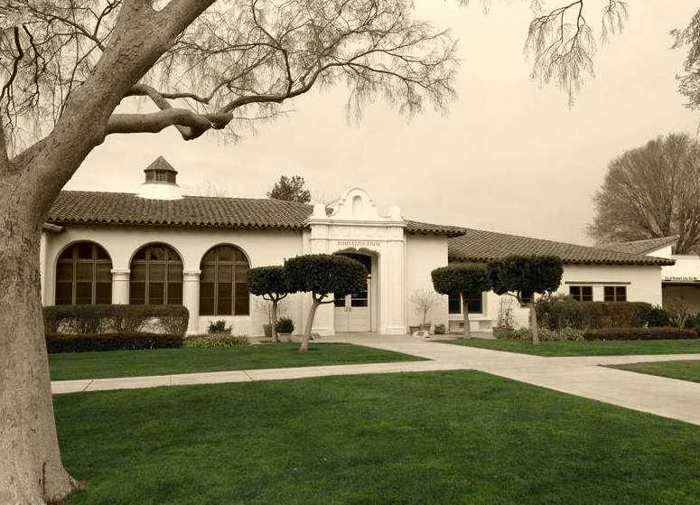
Chapter III: The Self-Study Process
- The involvement and collaboration of all staff and other stakeholders to support student achievement
In preparation for the formal self-study and writing process, the faculty devoted several staff development days to analysis and discussion of student performance data.
In order to involve more students and parents in the wasc process, the Leadership Team has employed a separate wasc Student Committee and a separate wasc Parent Committee, which have been meeting over the course of the self-study process to discuss and report on issues relating to the five Focus Group categories. The wasc Parent Committee contains and Spanish Speaking sub-group with an interpreter. The role of classified employees is unclear.
- The clarification and measurement of what all students should know, understand, and be able to do through expected schoolwide learning results and academic standards (note the selected expected schoolwide learning results examined by the school)
As noted in Chapter II, the school emphasizes the knowledge, skills, and habits outlined in the expected learning results. Measurement of the results of that emphasis appears to be more descriptive and anecdotal than gauged assessment, not an unusual procedure when dealing with long-range goals rather than specific and isolated skills. The school attends carefully to the California state Content Standards and the standards for Visual Arts.
- The gathering and analyzing of data about students and student achievement
The school has made major strides in the gathering and analysis of data on student achievement. A technician in the counseling office gathers and disaggregates data on students their achievement at teacher request. The Aeries Student Information System provides a rich array of data to students and parents and a complete record of all students achievement in every aspect of their lives at the school. Working in departments, in smaller groups, and as individuals, many teachers have become proficient at using those data to both adjust the content of their courses and modify the strategies used to teach it.
- The assessment of the entire school program and its impact on student learning in relation to expected schoolwide learning results, academic standards and wasc/cde criteria
The size and culture of the school assures that much discussion and informal program assessment takes place continuously. Administration and teacher efforts have moved the California content standards to the forefront of planning for instruction. Tradition and the University of California’s a-g application requirements, though, continue to drive much of the program.
- The alignment of a long-range action plan to the school’s areas of need; the development and implementation of an accountability system for monitoring the accomplishment of the plan
The school’s proposed action plan focuses tightly on the areas dictated by its program improvement charge. The staff report finding heartening in the data and improvement in critical areas since the previous wasc visit. They find, though, the continuating of the needs of the school’s Hispanic student population the primary area for increased improvement. The staff has generated a new set of Critical Academic Needs to guide them through the wasc process and program improvement:
- Increase attention to and resources for el (Limited English Proficient) students
- Increase attention to and resources for low performing math and English students
- Revisit and expand existing tutorial structure
- Increase the number of Latinos/Hispanics taking ap and Honors classes.
The school is clear, though, on its mission to serve all students. Although the primary trigger of reform has been the improvement of Hispanic student achievement, both the Academic Critical Needs and the eslrs target equally well the needs of all sub-groups struggling with achievement on the cst and cahsee exams as well as the student body in general.
The eslrs specifically tailored to addressing the new four Academic Critical Needs are those dealing with the development of (1) motivated and self-directed learners, (2) effective communicators, (3) responsible citizens (4) informed critical thinkers, and (5) effective users of technology.
The school has begun the process of dealing with the new challenges of program improvement by starting study of nine key elements:
- Exploring how to redesign academic support systems to address the needs of students who are not availing themselves of school-provided academic support opportunities
- Identifying programs or policies to assist el students in advancing language competency
- Finding areas of low cst performance to target and deciding what reforms should occur
- Selecting programs or policies to target the needs of students who underperform on the math and English cahsee
- Exploring policies and programs to encourage more Hispanic students to enroll in Honors and AP courses
- Adjusting the school vision and policies to accommodate the changing ethnic and social make-up of the student body
- Identifying new teaching and learning issues that will arise as the school population changes to include more Special Education students and English Learners
- Ensuring that Hispanic students are adequately represented in college prep, honors and Advanced Placement courses
- What factors might contribute to an achievement gap between Hispanic and non-Hispanic students and what steps might be taken to correct these factors?

Expected Schoolwide Learning Results
Motivated self-directed learners who choose to:
- Challenge themselves by pursuing rigorous academic coursework
- Utilize available academic and tutorial resources both independently and collaboratively
- Master English language proficiency as needed to achieve academically
- Identify and implement personal and academic goals
- Ask questions, complete tasks, and find solutions
- Persevere through setbacks and adversity
- Engage with classmates, instructors and curriculum
- Effective communicators who:
- Actively improve verbal and written language skills across a wide spectrum of ability
- Use language to effectively organize and articulate concepts and ideas through speaking, writing and other media
- Demonstrate comprehension of information delivered in written, spoken and graphic form
Responsible citizens who:
- Support the school community by choosing to master fundamental academic skills
- Recognize the importance of punctual daily attendance and demonstrate positive citizenship
- Demonstrate the knowledge and skills necessary to be an active participant in a democratic society
- Actively participate in the school community by contributing time, energy and talents
- Demonstrate respect for diverse cultures and individual differences
Informed critical thinkers who:
- Prepare themselves academically to apply acquired knowledge to higher level learning environments.
- Develop hypotheses to test solutions and resolutions to problems
- Interpret, analyze, synthesize and evaluate information in different environments
- Differentiate facts from opinions in a variety of applications
- Apply learned skills and concepts to new situations
Technology users who:
- Access school provided technological resources designed to increase core subject mastery
- Competently use basic hardware and software.
- Clearly present concepts and ideas using current and relevant technologies Are media literate and able to discern the reliability of electronic information
- Utilize existing and emerging technologies to increase access to core curriculum
- Use technology ethically and responsibly, adhering to academic integrity standards

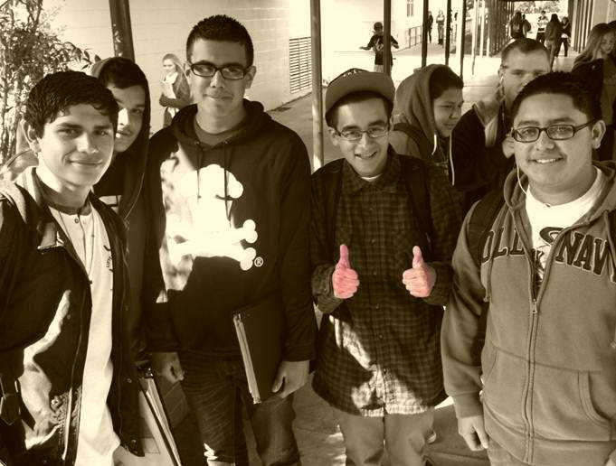
Chapter IV:
Category A: Oganization: Vision & Purpose; Governance, Leadership & Staff and Resources

A1. To what extent does the school have a clearly stated vision or purpose based on its student needs, current educational research, and the belief that all students can achieve at high levels?
To what extent is the school’s purpose supported by the governing board and the central administration and further by expected schoolwide learning results and the academic standards?
The teachers and staff discussed the criteria questions and the effectiveness of the school’s vision and purpose criteria in both small and large group settings. In addition, they have created and edited survey questions that address the essential questions for parents, students, staff, and teachers and listed evidence that illustrates how they meet the criteria.
The vision was created collaboratively by all stakeholders to provide a clear purpose of what all students should know and be able to perform. This vision is consistent with national, state and local standards. All stakeholders provided input and participate in the process of ensuring students are afforded a curriculum that is challenging, rigorous and meaningful.
The staff creates curricular and instructional goals based on the school’s vision. These are aligned with state standards and approved by the school board. The school is concerned about meeting students’ needs and actively reviews decisions and results. Parents, the community and students are made aware of grades, assignments and opportunities to meet to discuss, suggest and question teachers, and administration.
The primary purpose of the school’s vision is to create an environment that fosters the growth and development of all students. The eslrs support the vision of creating this positive environment throughout the campus each and every day. They also support the vision of encouraging all students to become successful citizens and lifelong learners. The staff believes in and embraces the vision statement and the eslrs.

A2. To what extent does the governing board have policies and bylaws that are aligned with the school’s purpose and support the achievement of the expected schoolwide learning results and academic standards based on data-driven instructional decisions for the school?
To what extent does the governing board have delegate implementation of these policies to the professional staff?
To what extent does the governing board monitor regularly results and approve the single schoolwide action plan and its relationship to the Local Educational Agency (LEA) plan?
The District has established clear policies and bylaws for the selection, composition, and duties of the board. The policies identify the frequency and regularity of board meetings. The board has developed policies and bylaws to support the achievement of state academic standards and the eslr’s established by the school. These policies have been established through the collaboration of all district shareholder groups. These policies are continuously reviewed by the staff at the district office as well as at the school site as they are implemented. Policy changes are also reviewed by all stakeholders at the school site (parent groups, student groups, and the various departments) before being implemented.
Implementation of policy is delegated to district administrators after a policy has been approved by the Board of Education. The application of the policy is the responsibility of all shareholders from site administrators to teachers in the classroom.
The Board of Trustees and district administrators review test data and other criteria to monitor progress in the implementation of policies. Data is then reviewed by site administrators and department chairs.
The Board of Trustees evaluates and monitors the successful implementation of policies and bylaws related to the review of student performance, overall school operation, and the fiscal health of the school. The board has established, and makes all stakeholders aware of, the uniform complaint procedure for conflict resolution.

A3. To what extent based on student achievement data, does the school leadership and staff make decisions and initiate activities that focus on all students achieving the expected schoolwide learning results and academic standards?
To what extent does the school leadership and staff annually monitor and refine the single schoolwide action plan based on analysis of data to ensure alignment with student needs?
Stakeholders work collaboratively to make decisions and initiate programs that ensure all students can meet minimum proficiency requirements for the California State Standards and the Expected Schoolwide Learning Results.
All stakeholders annually review the Single Plan for Student Achievement. The Single Plan for Student Achievement identifies specific tasks, the individuals responsible for each task, when the task will be performed, the resources to be utilized to perform the task, how the task will be monitored, and how the progression of the task will be communicated. Departments analyze test results in order to determine specific areas for growth and identify possible needed resources to ensure student achievement. In area of el, the school provides additional support to ensure opportunities for success for student with el status.

A4. To what extent does a qualified staff facilitate achievement of the academic standards and the expected schoolwide learning results through a system of preparation, induction, and ongoing professional development?
The school district has established employment policies that ensure highly qualified personnel are placed at school sites. The district has established an effective method of maintaining appropriate training and preparation through professional development opportunities. Staff assignments are based upon individual expertise to maximize student performance. The district has clear policies and procedures that define and identify the methods, practices, processes and relationships between leadership and staff. The district and school site have effective and open communication. The implementation of staff collaboration at the school has facilitated the involvement of all staff in the processes of shared responsibility, and accountability in support of student learning. These processes include the evaluation of strategies used to encourage improvement and innovation. The regularly scheduled collaboration meetings allow for the review of existing processes to determine how effective current practice is on student academic success.

A5. To what extent are leadership and staff involved in ongoing professional development that focuses on identified student learning needs?
The school has an effective support system for professional development and has been a host for an area wide staff development event. The school is dedicated to providing time, personnel, material and financial resources for staff development to ensure all students are meeting the academic standards and the eslrs. The school administration promotes and facilitates the professional growth of all staff members. Additional time for staff collaboration incorporated into the structure of the school schedule enhances the effectiveness of the techniques learned during staff development. Collaboration provides an effective operational process that determines the measurable effectiveness of professional development on student performance.

A6. To what extent are the human, material, physical, and financial resources sufficient and utilized effectively and appropriately in accordance with the legal intent of the program(s) to support students in accomplishing the academic standards and the expected schoolwide learning results?
School resources are allocated only when it can be demonstrated that the resources are going to be utilized in a manner consistent with the school’s vision and purpose, and will support student academic achievement as outlined in the Single Plan for Student Achievement. All staff members have input via direct communication with district personnel, regarding the allocation of resources. The district has operational processes in place to develop an annual budget, conduct audits and conduct business and accounting practices which ensure protections are in place against mishandling of district funds. Procedures are in place for the acquisition and maintenance of instructional materials and equipment necessary to ensure student academic success. The school has utilized available resources to enable the hiring of a highly qualified staff and to nurture staff through a myriad of professional development opportunities. The school’s action plan has established a process for timely examination of long range goals. The action plan details tasks that will ensure the continual availability and coordination of appropriate resources which support student achievement of the academic standards and the eslrs.

Strengths

- The district and school leadership teams function cohesively enacting a clear, student-centered vision.
- Communication between all stakeholders is open and positive.
- The site leadership, staff and counselors provide active and regular communication with community stakeholders.
- The school is a clean, safe, and orderly environment for students and staff.
- All stakeholders take part in the long term decision making process for school goals.
- District resources are utilized effectively to support student achievement.

Areas for Growth
- The school leadership needs to continue to expand educational and extracurricular opportunities for members of the Hispanic community.
- The school leadership needs to continue to expand communication opportunities for Spanish speaking parents.
- The school leadership needs to continue to increase articulation with feeder schools regarding the academic abilities and educational and language backgrounds of incoming students.

Important evidence from the self-study and the visit that supports these areas:
- Self -study document
- Meeting with district and site administration
- Classroom observations
- Dialogue with leadership team and focus groups
- Meetings and interviews with students
- Reports of analyzed achievement data
- Websites of the school, the district, and California Department of Eduation’s DataQuest

CHAPTER IV: CATEGORY B: STANDARDS-BASED STUDENT LEARNING: CURRICULUM

B1. To what extent do all students participate in a rigorous, relevant, and coherent standards-based curriculum that supports the achievement of the academic standards and the expected schoolwide learning results?
To what extent are the expected schoolwide learning results accomplished through standards-based learning (i.e., what is taught and how it is taught)?
The District has approved course syllabi and descriptions that meet California State Standards, indicating that the school has defined academic standards for each subject area, course and program. The mathematics department has indicated that textbooks are aligned to state standards for each math course and that math standards are posted in each classroom for students to become aware of topics of instruction and expectations.
To help keep the curriculum aligned with students’ entire educational plan, the school meets regularly with feeder schools and local colleges and universities. Recent efforts have increased student success with the transition to high school. Continued efforts towards alignment as well as increasing the skills and knowledge sets students arrive at the school is critical towards the Action Plan goal of increasing the number of students enrolled in higher level/AP courses.
Teachers occasionally collaborate to integrate common expectations and practices not only vertically within a department/grade level/subject area but also horizontally with other departments. Some instructors have planned units that correspond with other courses’ subject matter; integration among disciplines at the school is evidenced by joint projects that link such courses as English to U.S. History and Government to Statistics.
To help students see the relevance of the curriculum, freshman social science classes present a four-week career component aided by guidance counselors. Some students find more career education in marketing and merchandising, restaurant, and auto classes.
The school assesses the curriculum and its rigor, relevancy, and coherence through examination of course completion, credits, grading policies, and homework. It is not clear if this process is a regularized part of the school procedures. The school completes an annual review of course descriptions, prerequisites and a-g requirements. School-wide reading and writing practices have been defined and implemented across all disciplines. Teachers also collaborate within disciplines on grading policies and homework assignments. Core subjects administer quarterly common assessments, study the results, and make such alterations as identifying topics to “reteach” in English and places to adjust the pacing plan in math. It is unclear whether the process reviews of the work forms a challenging, coherent and relevant curriculum for all students.
Evidence of the use of current educational research to maintain a viable, meaningful curricular program for students is evident based upon the depth and breadth of courses offered as well as those approved by the University of California and added to the data base of the National Collegiate Athletic Association. [The viability of the program has wavered in recent years but with additional efforts to increase AP enrollment with underrepresented groups viability of programs should increase.] In the Advanced Placement program the school has been concerned in recent years by issues of consistency of AP exam success and of equity and access. The school’s Action Plan addresses the question of inclusion and proposes both new and increased efforts to build the AP enrollment of currently underrepresented groups.

B2. To what extent do all students have access to the school’s entire program and assistance with a personal learning plan to prepare them for the pursuit of their academic, personal, and school-to-career goals?
A rigorous, relevant and coherent curriculum is accessible to students. The school examines the demographics and abilities of students throughout the class offerings. The school’s instructional practices and other activities facilitate access and success for special needs students. Instructional practices and other activities are beginning to facilitate better access and success for underrepresented groups.
The Action Plan indicates that the school is focusing on accessibility of a rigorous curriculum to all students. It is apparent that the curriculum at each level is relevant and coherent; the action plan focuses on finding ways to establish whether it provides the appropriate level of rigor for each student. Special Education students are afforded multiple levels of coursework depending upon their needs. Teachers differentiate instruction when needed and make themselves available for extended tutoring in the event a student does not master a concept.
The school has begun to take steps towards assessing whether the curriculum and its rigor, relevance, and coherence is appropriate to all students based upon the examination of policies regarding course enrollment and completion in relation to under-served populations. The school offers a Hispanic Parent Night to inform parents of the course offerings. The Action Plan indicates that the school is increasing its efforts to raise enrollment in rigorous courses for underrepresented groups. Special needs students are regularly—and successfully—mainstreamed into more rigorous courses.
The staff has maintained articulation with feeder schools and local colleges. Some feeder schools have stronger articulation agreements than others, a disadvantage some students have experienced. Mathematics and English teachers lead the way with matriculation efforts through common pacing guides, benchmark assessments, regular meetings and intervention reviews. Agriculture and Auto Mechanics instructors collaborate with the local community college and reinforce their articulation with yearly meetings.
Students have numerous avenues through which they can access the entire instructional program. The community has noted that students have opportunities to make appropriate choices and pursue a full range of realistic career and educational options, but for several different reasons, some subgroups of the school are not enrolling in the most appropriate courses.
The school provides extensive opportunities for career exploration, preparation for post-secondary education, and pre-technical training. The robust rop course offerings in conjunction with such offerings as the honored programs in agriculture, and graphic and performing arts demonstrate that the students have more opportunities than most high schools can offer.
Students build and maintain a four-year learning plan to prepare them for their academic, personal, and career goals. Parents, students and staff collaborate in the development and monitoring of the plan based on the student’s learning style and career and educational goals. The counseling department oversees the majority of this effort, although it does not work in isolation. Special Education and 504 students receive additional support. Enhanced outreach systems have begun reach out to Hispanic families to ensure they have the information they need to make informed decisions. Admirably, the school has identified this outreach system as an area of focus in its efforts to even better inform and encourage under-represented groups of students to participate in various programs and courses.
Guidance counselors meet with students one-on-one to change and enhance their academic schedules and plans as needed. Counselors also make recommendations about AP classes, clubs, sports, and other activities that might meet the students’ academic strengths and interests. Staff refers to Aeries reports for grades and attendance regularly and can make course recommendations. The school has also partnered with “People Helping People” to provide at risk student with mentoring and alcohol/drug prevention, behavior and conflict resolution.
Other opportunities include an array of rop classes and concurrent enrollment in courses offered through Alan Hancock College. The avid program supports post high school transitions through college visits as well as special instruction in behavior and ideas for college-bound students. rop completes follow-up studies to learn about the effectiveness of the curricular program offered through rop. The school does not currently have a formalized system in place to track the effectiveness of the curricular program.

B3. To what extent are students able to meet all the requirements of graduation upon completion of the high school program?
The school’s graduation rate is 98.02%. The students are well able to meet the requirements of graduation upon completion of the high school program. The school provides a robust offering of opportunities for tutoring, labs, hands-on projects that include vocational pursuits including automotive, agricultural and visual and performing arts along with rop and community college opportunities.
Students acquiring English are afforded many avenues to meet academic standards through additional help in the classroom with adopted text materials, bilingual tutoring, migrant education, bilingual assistance and peer tutoring. The ELD program and social science sheltered classes support the success of el students. Faculty also works to mainstream special education resource students wherever possible. The school has designed developmental reading and language classes for assisting students who struggle in those areas.
The District offers several programs to guide students into meeting all graduation requirements. Aside from the cahsee math and language arts classes, tutoring is available in all core subjects at lunch and after school. read 180 helps students reading below grade level. The school also offers “comprehensive” English classes to assist students in moving between read 180 and college prep English.

Strengths
- Robust course offerings
- Good communication with parents in most subgroups
- Availability of technology and use of technology across the curriculum
- Application of standards in real world, 21st century projects

Areas for Growth
- Establishing a standard system for tracking graduates to get their comments on the effectiveness of the curriculum.
- Improving school to home and home to school communication and raising expectations within subsets of the school population
- Expanding and improving articulation and matriculation with feeder schools as a vehicle for increasing underrepresented groups in higher level courses.
- Stronger student intervention system for academically at-risk students and parents of those students
- Increased deliberate cross-curricular collaboration

Important evidence from the self-study and the visit that supports these areas:
- Self -study document
- Classroom observations
- Meetings and informal interviews with the teaching staff
- Meetings and interviews with students and with parents
- Demonstration of Aeries reporting system
- Course syllabi
- Displays of student work
- Meetings and interviews with students
- Reports of analyzed achievement data
- Examination of school website

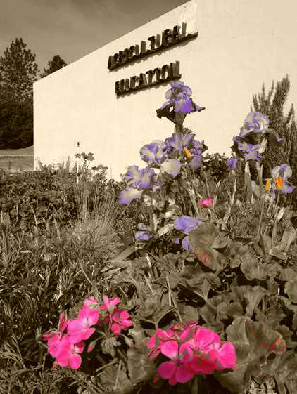
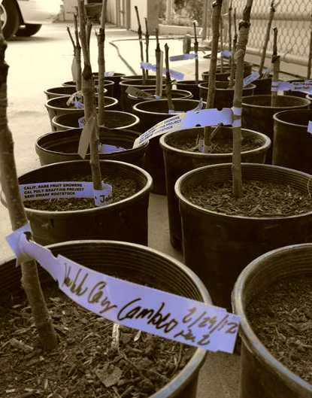
`

CHAPTER IV: Category C Standards-based Student Learning: Instruction

C1. To what extent are all students involved in challenging learning experiences to achieve the academic standards and the expected schoolwide learning results?
The staff members provide a challenging and rigorous learning experience to all students .There are over 30 sections of Honors and AP classes, three avid sections, and several on-site rop courses including Restaurant, Photo, Filmmaking, and Sports Medicine. The Special Education Department works closely with all regular education departments mainstreaming as many students as possible to offer the least restrictive environment. RSP, SDC and LH classes are also housed inside the regular education setting to allow students to foster good social ties and relationships. el students are assessed annually using celdt, reviewed for re-designation and mainstreaming into the regular program. Students who score below proficienct in math and English on the state tests are assigned to a 2-year Algebra I class, Read 180 classes, or both. There are some sheltered classes for el students.
There is evidence that the staff has examined disaggregated state testing data; they determined there is a need to diversify the student population in the more challenging honors and AP classes to more properly reflect the Hispanic population. This need has been identified in their Action Plan. Teachers did spend time visiting colleague’s classes. More visits could prove helpful in identifying and sharing best practices currently working for the el and low socioeconomic disadvantaged subgroups.
Students see the state standards written in the classrooms on posters, on assignments, on the syllabi distributed at the beginning of the year, and on teacher web sites.
The staff reviewed student surveys and interviews and established that most students reported they had multiple opportunities to think critically, although the opportunities increased with grade level.
Standardized test data is mailed home to parents each year. Student grades are mailed home four times each year with progress reports distributed mid-way through each quarter. Interviews with students and parents indicated that the Pirate Portal, the school’s Aeries system is used and appreciated. Data can be obtained on-line by parents, students and teachers through the school’s Aeries system. An evening program for Spanish speaking parents teaches computer skills so that these parents can become comfortable accessing this program.

C2. To what extent do all teachers use a variety of strategies and resources, including technology and experiences beyond the textbook and the classroom, that actively engage students, emphasize higher order thinking skills, and help them succeed at high levels?
The faculty is current on subject content and research-based instructional methodology. The staff has attended district sponsored workshops such as Jonathan Leaser’s two-day presentation on writing and reading strategies across the curriculum and Dr. Austin Buffo speaking on Pyramid of Interventions. A two-year BTSA program is required of all new teachers. All teachers have CTAP Level Two certification, and several have Level Three as well. Teachers have been instructed in and regularly employ SDAIE strategies in their classrooms. Teachers report an interest in having more input into the selection and planning of the staff development program.
All teachers are either clad or Bclad certified and each department has a member who has undergone avid training. All teachers have had in-house avid training and avid strategies are implemented across the departments. All Advanced Placement teachers have attended workshops in their respective subjects and a large number of teachers have also attended International Baccalaureate training as well. Teachers regularly attend subject area conferences. Several members of the faculty are fellows and consultants for UCSB's South Coast Writing Project or the UCSB History Project or Science Projects.
All classrooms have operating data projectors and digital overheads. Students use graphing calculators in a variety of math and science classes and drafting classes employ the latest CAD technology. Six computer labs and two mini labs for the read 180 program serve the school. There are computers in the library and in the adjacent presentation room. All classrooms have at least one computer and a digital presentation unit Student surveys and interviews showed a positive response to the use of technology throughout their learning experiences. Students favored opportunities offered in many classes to create movies, diagrams, Power Points, posters, and music montages. Teachers expressed a need for more training in the use of the technology.
Teachers provide students with rubrics, model papers, study guides and practice tests. They regularly discuss content standards during class and use standards posters as a reference for what students are expected to learn. While all teachers have websites to provide students and parents with access to homework, grades and upcoming tests, some are more up to date than others. In school surveys students specifically mentioned group work as a strong thread throughout their school day. The Committee saw fairly widespread use of effective group activities in a variety of subjects.
Students attend local plays, take field trips, and participate in community based student competitions. The school plans to have a program for Danish exchange students on campus in 2012.
The library provides vital support for academics. It affords a place for students to use technology, to meet for study groups, and gives an appropriate setting for completing schoolwork. The Committee found it in nearly constant use throughout the school day, with classes, small groups, and individual students using both print and electronic resources extensively.
Teachers from the English, Social Studies, Mathematics, Science and World Languages departments provide lunchtime, seventh period, and after school tutorials for both their students and other students who need help in their subject matter. There are plans to expand this program. In addition, an evening tutorial program meets on Wednesday nights in the library. Advanced Placement classes offer afternoon and evening study sessions in preparation for the national exams in May. The Math Department holds an Algebra I Boot Camp to help at-risk students become more proficient in Algebra.
Teachers use a variety of strategies and resources beyond the textbook that emphasize higher-order thinking skills including, but not limited to: direct instruction, teacher demonstration, SDAIE techniques, small cooperative learning group work, whole class/small group discussions, and avid strategies. Students are provided frequent opportunities to integrate academic and applied content through on-site rop classes. They have access to apprenticeships and on the job training, opportunities for internships, job shadowing, and listening to guest speakers.
Sports Medicine has students working for local physical therapists and doctors, and at high school sporting events. rop Restaurant also has students working in the community at local restaurants and hotels; they also prepare brunch and lunch for the high school and lunch for 2 local elementary schools. Horticulture works in conjunction with the city of Solvang to grow and plant flowers throughout the city and with Cal Poly San Luis Obispo. The east (Environmental and Spatial Technologies) program utilizes top-of-the-line technology in its project-based and science focused curriculum. It provides services to local community organizations when asked.

Strengths
- A wide variety of strategies to successfully teach core and elective classes
- The extensive on-site rop program
- Teachers who are well qualified and current in methodology and subject matter
- Teachers who are both equipped and comfortable with technology to support various learning styles
- Several teachers who are fellows in subject matter and literacy centered professional development groups

Areas for Growth
- Enhanced attention to helping teachers become more pro-active in encouraging capable Hispanic students to enroll in AP and Honors classes
- Continue investigation of methods to assist socioeconomically disadvantage and Hispanic students in achieving academic success.

Important evidence from the self-study and the visit that supports these areas:
- Self -study document
- Classroom observations
- Dialogue with leadership team, focus groups and key stakeholders
- Displays of student work
- Reports of analyzed achievement data
- Examination of school website
- Review of attendance sign-ins and group meetings

CHAPTER IV: CATEGORY D: STANDARDS-BASED STUDENT LEARNING: ASSESSMENT AND ACCOUNTABILITY

D1. To what extent does the school use a professionally acceptable assessment process to collect, disaggregate, analyze and report student performance data to the parents and other shareholders of the community?
Students are administered the mandated California Standards Test (cst) and the California high School Exit Exam (cahsee). English Learners are assessed annually using the California English Language Development Test (celdt) to determine their level of fluency. Student performance data, particularly for cst and cashee, are examined first by the Principal’s Council then analyzed by respective departments. Teachers review both overall scores and disaggregated results to determine what areas of the curriculum need to be modified, what courses need revision, and how the results of departmental and course assessments correlate with state tests.
Regular monitoring gives the School Board an accurate and current evaluation of student achievement, success of programs, and validation of educational decisions. School board agendas and packets include quarterly idms reports, student intervention data, tutorial attendance, end of course exam, cahsee, and cst results, thus demonstrating the regular review of student performance of the members of the school board. In addition, each month a different department presents to the school board.
STAR testing results and the California State Standards results are mailed home to parents informing them of individual student performance. Local media reports schoolwide results, comparing scores with other schools at the local, state, and national levels. The School Accountability Report Card is posted annually on the district’s website. The school’s assessment procedures contribute to the alignment of course contents with standards and the identification of weaknesses or gaps in student performance that may, in turn, identify modifications in curriculum or instruction.
Aeries Student Information System gives faculty and staff daily access to student information, standardized test scores, current and past grades. The system was implemented this year and some teachers are still struggling to fully utilize the system for grading and data acquisition. Student grade reports are mailed home four times each semester. The Pirate Portal in conjunction with the Aeries program provides staff, students, and parents with the ability to view test scores, current progress and grades in classes.
Teachers have collaborated to create common quarterly assessments in all core subjects and world languages. The science department has collaborated so that student labs are commonly assessed. Assessment strategies beyond traditional and mandated tests include a senior project, mock trials, and drama and productions, a variety of artwork, publications, and presentations for community agencies and groups. rop classes use industry-standard assessments.

D2. To what extent do teachers employ a variety of strategies to evaluate student learning? • To what extent do students and teachers use assessment results to enhance the educational progress of every student?
Teachers use appropriate assessment strategies to measure student progress toward acquiring a specific body of knowledge or skills. Those strategies include such techniques as:

- Essays
- Portfolios
- Individual and group projects
- Tests and quizzes
- Quarterly common assessments
- Lab reports
- Stage and music performance
- Discussions and talks
- Simulations
- Mock trials
- Senior Project

The English Department, as a district-wide mandated component of assessment, requires a senior project. The avid program allows avid teachers to monitor their students’ progress in their core classes.
Teachers meet regularly during collaboration time on Monday afternoons to collectively analyze data, share best practices, and design appropriate intervention for improving achievement by all students.
Students meet individually at least once a year with counselors to discuss and modify their overall progress, appropriate course level placement, and credit recovery needs. After each five-week grading period, counselors review grades and meet with students identified as needing intervention.
psat, sat, act, and ap participation and results are reviewed to inform teachers of the effectiveness of instruction and curriculum and to provide important information about student placement. The review of this data has also resulted in awareness of the need to increase the number of Hispanic students enrolling in advanced courses.
Special Education teachers and aides monitor students and collaborate with regular education teachers to modify learning assessments in accordance with 504 and iep Plans.

D3. To what extent does the school with the support of the district, and community have an assessment and monitoring system to determine student progress toward achievement of the academic standards and the expected schoolwide learning results?
District administration, the School Board, the site staff, students, and parents are all involved in the assessment and monitoring process of student progress. The school uses effective processes to keep the district, the board and parents informed about student progress toward achieving the academic standards and the expected schoolwide learning results. The Pirate Portal and the Aeries student information system record and report grades to faculty and parents for use in supporting student progress. Student grade reports are mailed home four times each semester. star testing results and the California State Standards results are mailed home to parents informing them of individual student performance. The School Accountability Report Card is posted annually on the district’s website. At the beginning of the fall semester, the school’s leadership team disseminates the cst summary reports to all stakeholders in the community.
The four core subjects (English, math, social studies, and science) provide three department-developed interim quarterly summative assessments and one teacher-created final assessment. Departments and the School Board use the results from these assessments to monitor progress toward department and district goals.

D4. To what extent does the assessment of student achievement in relation to the academic standards and the expected schoolwide learning results drive the school’s program, its regular evaluation and improvement and usage of resources?
The staff analyzes data by department to adjust, “reteach,” and monitor changes to curriculum and instruction to help close the identified achievement gap between White and Hispanic and between socioeconomically disadvantaged students and those more socioeconomically comfortable. Resulting actions include modification of scope and sequence, changing student placement, and the development of intervention strategies for lagging students.
The math department has negotiated articulation agreements with feeder middle schools and uses end-of-course Algebra and Geometry exam results in addition to standardized test results to properly place incoming 9th graders. A reading specialist from the high school tests 8th graders and Lexile scores are used to assess reading levels. Students not meeting the standards are placed into programs such as avid, At Risk Youth counseling, Read 180, and intervention mathematics programs.
Report and assessment tools are available in Read 180, the reading program for 9th and 10th grade students and English Learners who test below or far below basic on the cst. These tools provide teachers and school officials access to informative and detailed reports which help identify areas of deficiency well before state exams.
The school has established a new tutorial program to provide early intervention for students identified “at-risk” by their teachers using formative assessments and grading. Students referred to the program by teachers are required to attend tutoring sessions during lunch or after school. Data regarding effectiveness is not available.
The School Site Council uses data regarding student achievement to develop the Single Plan for Student Achievement (spsa) and allocates Title I, II, and state funds to address identified needs. The spsa is reviewed and approved by the School Board.

Strengths
- Aeries Grading and Attendance System and Pirate Portal provides access to student information, test scores, and grade history to school staff, students, and parents.
- Departmental quarterly common assessments are used in all core subjects and for world language classes.
- A special Monday schedule and a monthly “flex” schedule minimum day provides regular collaboration to review and analyze data in order to inform instructional and intervention activities
- Teachers use a variety of modalities by which students can demonstrate subject matter proficiency.
- Students participating in the avid program benefit from the monitoring and guidance of avid teachers.
- The District and the School Board actively monitor progress using assessment data that is collected, disaggregated and communicated to stakeholders.

Areas for growth
- The exploration, identification, and implementation by the school of formative assessments in all core subject areas and the modification of instruction based on the results of these assessments.
- The definition and implementation of procedures to measure and monitor the effectiveness of the tutorial intervention program
- Additional and timely staff training in such software systems as the Aeries system in order to fully utilize the features and capabilities available for grading, retrieving information regarding students, and analyzing data.

Important evidence

- The school’s wasc self-study
- Aeries system and Pirate Portal
- cst, cahsee, and celdt scores
- Tutorial intervention records
- Departmental quarterly common assessments
- Collaborative goal setting and assessment in faculty and departmental meetings
- Single Plan for Student Achievement
- Interviews with administration, faculty, students, and parents about assessments, availability and use of data, and accountability.
- Teaching staff grading criteria
- Agendas of faculty and departmental meetings
- Agendas of School Board meetings
- Classroom observations

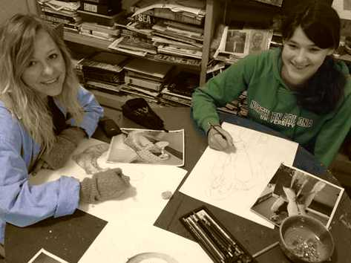
CHAPTER IV: CATEGORY E: SCHOOL CULTURE AND SUPPORT FOR STUDENT PERSONAL AND ACADEMIC GROWTH

E1. The school leadership employs a wide range of strategies to encourage parental and community involvement, especially with the teaching/learning process.
The school leadership employs a wide range of strategies to encourage parental and community involvement, including technology (email, websites with links and a Spanish “mirror” site, a parent portal, Aeries information system), a student handbook for all students, and report card mailings to homes. Aside from annual Back to School and Open House nights, an Art Night each Thursday evening is open to the public. The counseling staff offers several parent nights including meetings on college entrance requirements and financial aid, registration procedures, and grade level information. One counselor and the student services secretary are bilingual. In addition, numerous mailings and discipline and attendance paperwork are sent home with a Spanish translation. The bilingual counselor has created a “Spanish-Speaking parent Information Night.” The School Site Council provides an avenue for parents and community members to have direct input in decisions, and one member serves on the District English Language Advisory Committee (delac).
The school enjoys a variety of alliances with local community groups, including the Chumash Reservation, local businesses that work with the rop classes, the Santa Ynez Valley Youth Association, Rotarian Club, Elks Club, and Booster Clubs. The school’s Future Farmers of America (ffa) is involved in numerous competitions and exhibitions in both Santa Barbara and San Luis Obispo counties as well at national conventions and has partnered with the farm bureau. Finally, guest speakers from university systems and the military frequently visit the campus and provide current information about their programs. The District has facilitated a partnership with the International Business School of Denmark that will accommodate upwards of 30 students starting in the 2012-2013 school year.

E2. The school is a) a safe, clean, and orderly place that nurtures learning and b) has a culture that is characterized by trust, professionalism, high expectations for all students, and a focus on continuous school improvement.
The school provides a safe, clean, and orderly place for learning. Students, teachers, administrators, and classified staff work together to create on-going policies that promote student learning and staff productivity. The campus has an “open” feel and is an attractive facility which supports athletic events, theater presentations, art shows, and various organizational meetings held regularly throughout the year. The school has installed a coordinated camera security system which views a large portion of the campus and provides recorded video information for use of the administration. The district supports a well-trained maintenance and custodial staff that beautifies the campus. One custodian lives on campus to ensure security and is available 24 hours a day. The campus is monitored 8 hours daily by two campus supervisors and a resource officer from the Santa Barbara County Sheriff’s department, all of whom can have radio contact with administrators at all times. The administration has promoted a sense of personal responsibility for all students to pick up trash, one which resonates across campus. An administrator circulates on campus during morning break and lunch and visits 9th grade classes to review behavior policies with incoming freshman.
Each student receives a comprehensive discipline handbook that outlines school policies regarding behavior and attendance. The implementation of color-coded passes for the school year 2011-12 is helping to monitor the students according to their location and nearest restroom. The high school allows seniors with a 2.75 cumulative grade point average to leave for lunch with parent permission. Off campus privileges may be revoked for if tardiness or attendance issues. Attendance is monitored closely. “Tardy Sweeps” are conducted by the administration, teachers, and campus security every month or quarter. The school uses a phone master system that automatically calls the home of any student who misses one or more periods per day. Teachers can send defiant students to a designated room for supervision, which is staffed each day by a campus supervisor. This room is also used for students serving on-campus suspensions. Teachers provide their assignments, and the campus supervisor oversees the work.
The administration and support staff have designed a safe school plan for the high school including the implementation of regular fire and disaster drills. The school’s crisis team meets under the direction of the head counselor and updates emergency phone trees, and staff safety assignments. In addition, an emergency Hot Line rings at the Student Services Office and brings a rapid response from administration and supervision.
Positive citizenship is celebrated and supported in a variety of programs, including Advancement via Individual Determination (avid) and National Honor Society. Student athletes perform community services hours as part of their program. Approximately 35 students are members of the school’s “buddy program,” founded to encourage social friendship among disabled and non-disabled students. An outstanding senior is recognized monthly to showcase students who achieve high academic standards and positive citizenship, and pictures of graduates now attending four-year universities are displayed in the administrative building. A senior awards program recognizes students for academic achievement, and athletic recognition occurs through All-League, California Scholastic Federation and Scholar Athlete awards. Cultural awareness is enhanced through school clubs and activities such as Leadership Camp, Chalk Festival, and the largest club on campus—OLA, the Organization of Latinos & Americans. Many faculty and staff are involved in extended professional development opportunities, including summer training programs such as the California Writing Project, the California-History/Social Science Project, the California Math Project, impact II Grants and avid workshops. Additional training and professional development for teachers related to instructional technologies would further enhance use of these devices.

E3. All students receive appropriate support along with an individualized learning plan to help ensure academic success.
To what extent do all students receive appropriate support along with an individualized learning plan to help ensure academic success?
An individualized learning plan, created in partnership with the student, the parent, and the school counselor, exists for every student. The school has contracted with Naviance, a commercial provider of on-line tools used “to develop and manage multi-year plans for every student to chart a path toward graduation while achieving college and workplace readiness.”
All students are required to enroll in six classes. Seventh period enrollment is required for all freshmen and highly recommended for students lacking credits. To ensure both a coherent and rigorous standards-based program for all students, alternative instructional options exist (avid, Algebra 1/2, Read 180, etc.) which allow access to and progress in a-g required courses.
Students with special needs are also allowed access to rigorous curriculum. Special education students are mainstreamed to the highest degree possible. The Santa Ynez Valley Special Education Consortium works with the site administration to evaluate and supervise the special education academic program the school. Recently, greater emphasis has been placed on teacher support and input at Individualized Education Plan (ip) meetings.
The el program offers a rigorous, standards-based curriculum to students. The literacy-rich curriculum is designed to help students rapidly acquire English fluency. The el counselor, the el teaching team (eld and Read 180 teachers), and the principal evaluate el student classroom performance each school year. The school follows the State Board of Education’s reclassification guidelines when re-designating a student from English learner to fluent English proficient.
The school holds two 8th grade parent information nights (given in Spanish and English) in March preceding the students’ 9th grade year. Counselors mail registration materials in early spring each year to inform parents about March orientation dates and the times of individual student meetings that will take place at the feeder schools. Later, the counselors visit each local elementary school and meet with individually with each 8th grade student.
Counselors visit the all 9th grade Health classrooms in December and January to have students complete a learning style inventory through Naviance, a commercial, web-based college and career guidance program. During the year, the counselors meet individually with each freshman to review group information and design a 4-year plan, provide a copy of the plan for the student and mail a copy home to parent or guardian, hold a 9th grade evening parent meeting for parents of freshmen to provide freshman specific information and meet in March with students to fill out their schedules for the next year.
Counselors visit 10th grade social studies classes to deliver informational presentations and have students use Naviance to complete personality assessment and career research. During the year, the counselors meet individually with each sophomore to review group information and to update and complete the 4-year plan. They provide a copy of the plan to the student and mail a copy home to parent or guardian, hold a 10th grade evening parent meeting for parents to discuss college planning, financial aid, and provide sophomore specific information, and meet in March with students to fill out their schedules for the next year.
Prior to start of the junior year counselors review each junior transcript to identify students at risk of not graduating. They meet individually wherever possible with each at-risk junior student and parent to complete an evaluation and recommendation form. The counselors monitor the students closely through Aeries, document interventions, and meet individually with each junior at risk after each grading period to assess progress and adjust the student’s program. At the beginning of the school year counselors visit all 11th grade English classes and distribute packets of information that include four-year college information, financial aid, and sat/act testing information. They also have the juniors complete a college search and research through Naviance. During the year, the counselors schedule a parent information night and meet in March with students to fill out their schedules for the next year.
In August the counselors review each senior transcript, complete a senior graduation update form for every senior, and identify all at risk senior students in danger of not graduating. They also meet individually with each senior at risk student and parent, if possible, complete the at risk evaluation/recommendation form, monitor more closely through Aeries and document Interventions, and meet individually with each senior at risk after each grading period to assess progress and adjust program as needed. The counselors visit all 12th grade English classes in September and distribute packets of information that include the students’ transcript, four-year college information, financial aid, and sat/act testing information. They have seniors complettheir personal information update and college search and research through Naviance. During the year, the counselors make regular, scheduled visits to the senior English classes to give scholarship and financial aid information and assist students with the college application process. To help with college financing, counselors provide a financial aid night in early January to provide information on the fafsa, a financial aid workshop February to assist parents and students with the submission of their fafsa, and a senior exit survey online through Naviance.
A guidance technician compiles national, state, regional, and college scholarships into a scholarship handbook mailed to all seniors in September. The school bulletin and the website advertise current scholarships throughout the year. In March, the technician organizes and advertises the local scholarships and in May, decorates, and orchestrates the Senior Awards Night.
Students report that they feel well-informed about their progress toward graduation and toward college and career goals.

E4. Students have access to a system of personal support services, activities and opportunities at the school and within the community.
The school has a wide range of services, activities, and opportunities supporting personal growth for students. Aside from a the guidance secretary and guidance technician, there are 3.8 full-time academic counselors, a 30% counselor for students with personal issues, and a 20% counseling intern from People Helping People (php) for students with personal and drug or alcohol concerns and a full time psychologist provided by the Santa Ynez Special Education Consortium. The Healthy Start program, operated by the php, provides additional support services such as career, homework, tutoring, and translation assistance. The school’s sst, comprised of a guidance counselor, guidance secretary, and teachers meets on an “as needed” basis with the parent(s) to determine how best to help a student academically. The in-house suspension program also assists students by keeping them at school and allowing them to get class work done. It also assists teachers by allowing them to remove a disruptive student from the classroom to another secure location on campus. These are segments of the Pyramid of Interventions.
In order to provide students with community service experiences, campus clubs and service groups such as Associated Student Body, ffa, and National Honor Society are involved in a variety of ways to serve the community. nhs and ap Calculus students provide in-house peer tutoring. For a relatively small high school, the athletic department offers an extensive program, including 22 varsity sports and can field up to 48 teams.
The master schedule’s focus ensures that all students have access to a rigorous, standards-based curriculum that meets their individual needs. All students have access to the academic courses they require to meet their individual learning plan. Finally, the Healthy Start Office, run by the People Helping People non-profit agency, is located on campus and provides myriad support services that assist students and families, including Medi-Cal applicaiton, collaboration with local feeder schools and family resource centers, local transportation, and academic mentoring programs. In addition, the Youth Down to Business program provides career counseling and job placement for eligible students.

Strengths
- A wide variety of academic, athletic and organized club opportunities for students
- A safe, clean and well run school site to support student achievement
- Teaching, administrative and support staff who can assist students with academic and personal decisions.

Areas for Growth
- Investigation of alternate methods to help Hispanic parents support their students academically and in extra-curricular opportunities.
- Enhancing opportunities for students to learn personal finance.
- Determination of methods that effectively increase participation for Hispanic students in extra-curricular activities

Important evidence from the self-study and the visit that supports these areas:

- Self -study document
- Meetings with Leadership Team and focus groups
- Classroom observations
- Meeting with parents
- Meetings and interviews with students
- Interviews with classified staff
- Dialogue with leadership team, focus groups
- Online articles from local newspapers
- School and district web sites
- Informal interviews with community members and former students

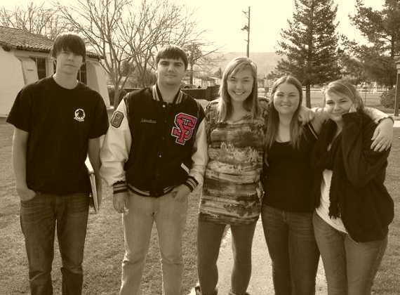
Schoolwide Findings

Schoolwide Strengths
- The highly qualified, dedicated, and caring teaching and support staff
- The robust course offerings including the extensive ap and on-site rop programs
- The effective use of collected and disaggregated data to drive instruction and inform decisions
- The well-equipped, attractive, clean, and safe campus
- The broad range of teams, clubs, and extracurricular activities that draw a high rate of student participation

Schoolwide Areas for Growth
- Determination of methods that effectively increase participation of Hispanic and of socioeconomically disadvantage students in ap and Honors classes and in extra-curricular activities
- Continue investigation of methods to assist Hispanic and socioeconomically disadvantaged students in achieving academic success
- Investigation of alternate methods to help Hispanic parents support their students academically and in extra-curricular opportunities
- Expand the opportunities to evaluate the effectiveness of the curriculum for all students through such strategies as tracking graduates to get their comment

Chapter V: Ongoing School Improvement

The Schoolwide Action Plan
The current draft of the action plan addresses:
- Hispanic student enrollment in AP and honors classes
- Improving academic proficiency for English Learners
- Improving core curricula proficiency for lower performing students
- Monitor the balance of the exam success rate on ap exams among the disciplines

School Improvement Issues
The first three sections of the action plan grow directly from the critical areas the school identified repeatedly in their study of the five criteria of the self-study process and in the report. The Committee agrees with the importance of the concern for lower achieving students, the students learning English, and the school’s Hispanic population. In its concern that its efforts encompass the entire student body, the Leadership Team is adding a fourth element to the plan. The Committee finds that addition wise. The sections of the plan address student learning directly, and steps in the plan are calculated to enhance student learning and to monitor closely that enhancement. The school has the resources to carry out the plan and to monitor progress.
Commitment to the plan is strong among the teaching staff and the school and district administration. All three groups played major roles in the identification of the areas of concern for the self-study and are dedicated to attending to those concerns.
The action plan finds additional support in its alignment with the school’s Program Improvement efforts, aimed at raising the measured achievement of students in the same subgroups. No serious impediments should stand in the way of the school’s success with the plan. The steps require only modest funding, all of it already earmarked by the district. The staff development efforts, organized by the Leadership Team and administration and built on recommendations from the teaching staff and school community, will help keep the school on the path it has set out for itself.
The school is solidly on track in its forming of a clear and logical system for monitoring accomplishment of the action plan. The follow-up process is already adequate, and the staff is adjusting pieces to make it an even more valuable part of the plan. Each subset in the plan has an identified timeline and reporting system.
The Visiting Committee is convinced that Santa Ynez Valley Union High School is ready to identify, implement, and evaluate ways to continue to enhance student learning as it builds on its enviable record of successes and its long, rich traditions.

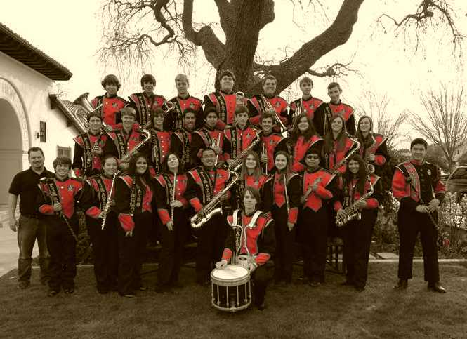
cover artwork by Megan Savage

